**Kumaraguru College of Technology, Coimbatore**

**Department of Information Technology**

**U18ITI5201- DATA MINING TECHNIQUES**

**Academic Year: 2024 – 2025**

**Naïve Bayes Classification [CO3, K4]**

1. For the given dataset, **apply naïve bayes classifier** to build model and predict class label for the test set (Overcast, Mild), (Sunny, Cool), (Rainy, Hot) using python scikit.[K3]

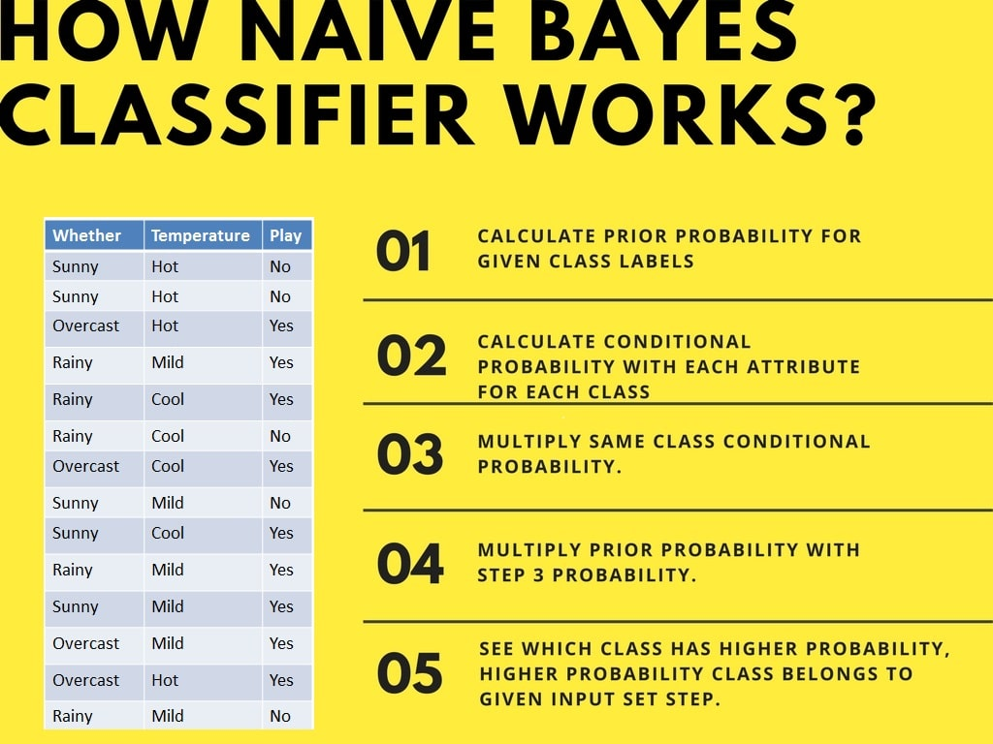

**OR**

1. Download “pima-indians-diabetes.csv” dataset. Load the dataset and **implement Naïve Bayes Classification algorithm** using python. Divide the dataset to Training set and testing set. Calculate probabilities and build prediction model. Print the Prediction for Test set and accuracy.

**Reference Links:**

<https://dzone.com/articles/naive-bayes-tutorial-naive-bayes-classifier-in-pyt>

<https://www.datacamp.com/community/tutorials/naive-bayes-scikit-learn>

|  |  |
| --- | --- |
| **Experiment Split-up** | **Marks** |
| Problem Analysis (5) |  |
| Program and Output (15) |  |
| Viva (10) |  |
| Total Marks (30) |  |
| Signature |  |